**Rizal Technological University**

Institute of Physical Education

**MOTIONLIT WEBSITE: TEACHING MOTOR LEARNING IN PHYSICAL EDUCATION THROUGH DANCE AND SPORTS**

Project-Based Learning (PBL) Output

Delgaco, Rica D.

Alota, Benjamin Jr. III A.   
Ramos, Jonas I.  
Yangga, Jomari C.

IPE-01-601A MH 1:30 pm- 3:00 pm

Professor Mark Joseph D. Santos

Abstract

This study aims to provide detailed information and sample demonstrations about motor learning in dance and sports to deeply understand motor learning in physical education in a blended learning modality. The study utilized a website called “MotionLit” and it is a classroom-inspired desktop user-friendly operated to effectively teach the student about motor learning in physical education. The researchers interviewed six (6) professionals and two (2) students and asked for their feedback in MotionLit website. As a whole, the findings implied that most of the respondents commended the website design for its creativity, navigation and features embedded in the website. However, some respondents suggested adjusting some parts of designs and features. This concludes that most respondents were visually attracted to the materials that are appealing to their eyes as well as fussy and observant readers because they focused even on the small details and they preferred functional features on the website to keep it more effective and worthy of time use. It is hereby suggested that the MotionLit website should upgrade its code to make it available even for small screen users and more visually appealing. The majority of the respondents valued the MotionLit website content as informative and easy to understand, however some respondents recommended adding other genres of dance aside from folk dance, and choosing one among dance and sports to provide more examples and a deeper understanding of the topic. This also concludes that most respondents were knowledgeable enough about the topic that allows them to critically analyze its content and significance in learning. It is hereby suggested that even though the MotionLit website provided well a comprehensive discussion and knowledgeable content about motor learning in physical education through dance and sports, it still needs to cover the other genres in dance too so that dancers who love other genres aside from folk dance will also be engaged and interested to it. It needs to include more demonstrations to incline the student’s psychomotor learning to assure understanding of the topic.

Introduction

Movement is the center of any steps we’re making. People’s movement reflects the motor learning implied. In this time of disease and uncertainty, movement acquisition shouldn’t stop because it is the foundation of making broader actions. Little do students know that in simple actions they do, they acquire motor learning before it became a motor skill. During this time of the Covid-19 Pandemic, limitations on social life and education were slow because of the spread of the virus. That leads to an increase in social isolation and limitations on travel, social gatherings, on-site work, leisure activities, and sports. School attempts to continue learning through distance learning tools such as blended learning modality (Filiz and Konukman, 2020). According to Gazali and Mujiono (2021), in today’s setup, educators and students face challenges in learning modalities in online learning of physical education. Amidst the pandemic, online learning on physical education became a struggle for most students and they see it as ineffective.

A growing number of researches mostly associational studies reveal that the connection of movement expertise together with mental components of development is highly observed in the early stage of children. Those children who attain movement competently will have a better intellectual capacity (Capio et al, 2021). Most of the resources such as literature, research, and studies about motor learning in physical education focusing on dance and sports are made and take place internationally. The Philippines has a lack of resources and studies related and could contribute to the area of study. Face to face classes before the pandemic, physical educators effectively discusses the motor learning in physical education on dance and sports but nowadays, learning in physical education takes place in distance learning tools like blended learning modality and it is a huge challenge for physical educators to promote learning since it is more on movement application activity. Apriyanto (2021) stated that most students during online activities do not attain major impacts physically and psychologically. Students much prefer a mix of learning online and offline. Students are a high level of interest in using online platforms given by teachers as well as approaches under online learning methods. This study is intended to bridge the gap between internationally available resources and the lack of local resources in the Philippines as well as provide more learning opportunities and understanding to students in motor learning in physical education through dance and sports from face-to-face classes to blended learning modality using MotionLit website.

This study aims to provide detailed information and sample demonstration about motor learning in dance and sports to deeply understand physical education in a blended learning modality by which students could read and watch directly on the website or could print out the lectures and activities at their home.

Methods

The study utilizes a website called “MotionLit” as the main platform for imparting knowledge to students. MotionLit is a classroom-inspired desktop user-friendly website that will be operated to effectively teach the student about motor learning in physical education through dance and sports by using a blended learning modality. It has a tagline “LEARN AS YOU MOVE” which emphasizes learning as they execute given movements. It also highlighted that in every basic dance step and sports skill, motor learning is present. A blended learning modality is used through MotionLit’s online and offline features. MotionLit Online features offer extensive discussion using video lectures, and quiz videos as well as links to other media platforms like the MotionLit Facebook page and MotionLit email where they could message their questions and feedback and send their works, also MotionLit google drive and MotionLit YouTube channel where they could watch and download the posted videos, while MotionLit offline features offer downloadable files of the lecture hand-out, quiz answer sheet and answer key. The target objective of the website is to allow students experience the virtual classroom set up through enrolling in virtual classes, to provide comprehensive discussion and knowledgeable content about motor learning in physical education through dance and sports, and to include multiple applications and social media platforms to maximize the use of a blended learning modality.

MotionLit provides two virtual classes such as dance and sports where students could imaginatively enroll themselves. Students don’t need to log in or make an account to explore the website. A student may proceed to MotionLit virtual hall to choose among two virtual classes that they are interested in, such as the dance class and sports class. Each room provided voluminous information, video lectures, and quizzes as well as downloadable lectures, quizzes’ answer sheets, and answer keys about motor learning in physical education focusing on dance and sports. In this way, students may be able to learn according to their learning style as well the availability of their internet connection. MotionLit also provides a virtual forum that serves as a platform for other researchers or experts to contribute their works and knowledge towards motor learning in physical education through dance and sports. Aside from that, readers may be able to share their thoughts, comments, suggestions, and questions through the virtual forum.

The initial stage in the creation of the MotionLit website is to address the driving question “How can I teach physical education effectively to my students by having a vast idea of motor learning using the blended learning modality?” From there, the group collaboratively discuss the strategies, website design, coding, content, and objectives, and consultation with the professor was also included. There is also dissemination of tasks, responsibilities, and assigning the deadline as well as the gathering of information needed for the website and research study. After gathering, there’s also the compilation of information gathered by researchers in the website content and research study as well as redesigning and embedding necessary content in the website. Video Editing is even used since it requires video lectures and quizzes to be uploaded to the website. To maximize the use of different platforms that may be used, we made a MotionLit Facebook page, MotionLit email, MotionLit google drive, and MotionLit YouTube channel where readers and collaborators could message questions and feedback, send their works, watch videos and download files. After those processes, we published online the website through the guidance and help of our IT friend. The next stage will be the professional and student-respondent’s trial in exploring the website and presentation of the project. Lastly, the researcher gathers the recommendations and opinions for further improvement of the MotionLit website.

**Review of Related Literature**

* 1. **Motor Learning in Physical Education**

Spittle (2021) mentioned that Motor learning and skill acquisition refers to the exploration of how we acquire, develop and progress skills in moving. Physical Education and sport aim to assist in skills acquisition. Motor learning deals with the study of the development of skilled movements along with repetitions or other learning-associated components. He also stated that Motor learning experts at colleges and universities play an important role in undergraduate and postgraduate individuals. Subjects under motor skills learning such as motor control, movement skills, motor development, motor learning and skill acquisition, coaching, and physical education. Aside from teaching academically, physical educators proceed to postgraduates’ fields, like masters and doctoral studies concentrating on the acquisition of motor skills in physical education and practice these learnings in teaching elementary and secondary schools- they are also classified as skill acquisition specialists.

According to Donelly et al (2016), the goal of physical education is to motivate and enhance learning to move as well as to have learned through movement. Physical Education barely a learning area existing in the curriculum that emphasizes enhancing students’ movement skills and concepts. In physical education, the enhancement of motor skills is vital by which if there will be a failure in enhancing and smoothening movement skills, it will be hard for children to prosper and appreciate physical activities and active lifestyles.

Blasing et al (2012) concluded that Simple skills are completely acquired by the neuromuscular system that chooses the most effective method to attain the goal in movements. That leads to increase usage of abilities as well as decreased use of energy.

As mentioned by Capio et al (2021), after a lot of research, mostly in associational studies, it reveals that the connection of movement expertise together with mental and social components of development is highly observed in the early stage of children. Those children who attain movement competently will have the better intellectual capacity and social behaviors.

D’isanto et al (2016) elaborated that motor learning refers to emerging most articulated motor programs that will result in a prescription of teaching motor activity through managing student exercises that alleviates motor program and reduces inconstancy of execution of movement.

* 1. **Motor Learning in Dance**

According to Krasnow and Wilmerding (2015), Motor learning in dance signifies dancers that learn both easy and difficult skills. These skills are not acquired from the motor development that happened for all children like grasping, skipping, and walking. Dance instructors aim to teach skills for them to execute movements with exactness, synchronization, articulateness, and smoothness, with memorization. Dancers’ goal is to attain a level of competency that develops the quality of movement.

Krasnow (2013) emphasizes that motor learning is the extent of education that criticizes how dancers acquire new movement but not only for one class or practice session. The term motor learning is used to describe changes acquired through practice and are lasting or recalled at some point.

Karin (2016) discussed that, in ballet, the method of conveying complex techniques to young dancers can appear in an innate manner that grows effective, expressive, and synchronous movements.

Coker (2017) claimed that practice is a crucial aspect of learning or re-learning a motor skill. To maximize one’s time, rehearsals should provide differences in regular and irregular conditions in any setting. It is desirable to practice variability to be determined and instructors should choose how the practice session is managed.

According to Gose (2018), dancers as part of their everyday training equally acquired motor learning as well. In dance, motor learning happens in areas like learning styles, practice schedules, feedback, directions, memory, and attention.

* 1. **Motor Learning in Sports**

Spittle (2021) stated that the acquisition of basic skills in sports allows players to take part in activities. Having a higher level of sports involvement, and proficient execution of movements are critical variable that affects competent performance. He also discussed that there are categories of skills based on the accuracy of movement (gross to fine), arrangement of skill (discrete, serial, and continuous,) and constancy of the environment (open to closed).

As mentioned by Masters et al (2014), the adequately complex motor task requires a connection of many degrees of freedom. As skills oblige to have a competent performance like most sports activities, learners should have a proactive role in the learning process that can be managed or supervised consciously.

As discussed by Agosti and Madonna (2020), In teaching movements, to a child or an athlete, it is important to comprehend well the motor function as an arising factor of a complex system where movement occurs through motor experience, later became an actor, and proceeds to be a motor performance.

As mentioned by Di tore and Raiola (2017), the most used old teaching practices base on theories in cognitive approach and prescriptive teaching vision. The cognitive approach refers to one’s psychological model of motor learning such as open-loop and closed-loop motor control models as well as generalized motor program theory. Some scholars focus on sport’s teaching method from a different point of view namely the ecological approach. In this part, coaches focus on school environment settings and interpretation of learning as a study for physical and motor resolutions existing in the environment. This approach is based psychologically on the theory of Bernstein’s degree of freedom and motor imagery.

Kal et al (2018) stated that implied motor learning is known to be specifically efficient for acquiring sports-related motor skills. There will be an automatic movement that help with multitasking and high-pressure environment movements.

* 1. **Physical Education in Blended Learning Modality**

Burgueño et al (2021) claimed that physical educators examined that blended learning implied over workload, exacerbated social relationships, worsen students’ motivation. Similarly, physical educators view physical activities performed in blended learning by students as lower than normal. Moreover, teachers stated that students with low economic status because they lack gadgets and resources.

As expressed by Derri et al (2012), the blended learning modality is a fusion of offline and online learning that comprises the suitability of online courses even without face-to-face benefits. As alternative teaching methods, blended instructions should be used by teachers to help students improve their school performance.

According to Chen and Li (2016), as network information technology continue to develop, the emphasis on teaching sports in Physical Education College and universities with computer association, blended learning will manifest. Blending learning comprises a new teaching model, old physical education teaching, blended learning applications, developing the efficacy of teaching computer lessons of physical education, Sports College, and network computer teaching. From there, students will be able to completely accomplish the task and will attain the target objectives and requirements of practice teaching.

Buschner and Daum (2014) explained that blended and online learning physical education is only applicable for high school students when they already executed motor and social skills to be competent online students. The main goal of physical education is to enhance motor skills and the problem related to evaluating motor skills through online, blended, and online learning physical education is not suitable for elementary students.

As mentioned by Ali et al (2022), one of the subjects that have significant problems is the Physical education subject. Those problems are produced by other matters. First, it is because of the content characteristics called movement activity. Prioritizing physical movement activities to attain learning objectives thru the help of the scientific approach steps and principles that are considered as factually cognitive activities is hard to show as subject content characteristics. Second, when the Physical educators failed to interpret, define, and disseminate the scientific approaches principles into the educational plan, it is because the scientific approach components in Physical education subject are divided from the entire learning material and it takes at least 10 to 15 minutes once it is applied into learning practice. With that, we can assume that the application was not accurate to the goal. Third, the time allotted for physical education subjects is not enough. Fourth, the facilities and infrastructure in many schools in Indonesia for Physical Education practice are very limited. Creating the subject application is controlled by many factors that are not connected to the subject content. Physical educators believed that one of the benefits of using digital technology and information technology management is to apply a scientific approach to organize course material content without limiting the learning period allotted for Physical Education subjects. The course content can be organized online or offline outside the course period thru digital devices. With the help of digital devices, educators can provide assignments, between physical activity homework and movement analysis or knowledge-based activity homework.

**Results**

The researchers interviewed six (6) professionals and two (2) students and asked for their feedback in MotionLit website.

In the interview with a respondent working in the Education field as a Physical Education teacher, R1 stated:

“Good points: creative and good color combination was used, easy to navigate, catchy header and important contents were provided. To improve: use some catchy font, as well as the size, needs to increase, emphasize the essential info, and watermarks on the contents like a hand-out, worksheet blocks some of the info. ”

In the interview with respondents working in the Dancing field as Choreographers, R2 mentioned:

“It is a nice program because it maximizes the use of social media which is the number one tool in learning during this pandemic. Through this program, you can easily educate people about the importance of Physical Education. Recommendations: 1. you should define first the meaning of dance before going to its benefits 2. You only focus on the definition of Folk dance, maybe you should include other genres because some people that may explore your website might not interested in folk dance only.”

R3 even stated:

“Being a physical education teacher that promotes physical activity and fitness acquisition through a comprehensive curriculum focused on lifetime involvement in sports and activities. I congratulate you and am happy to say a GOOD JOB! To all the people behind this website the “MotionLit”. Through the help of this website it can deliver an online dance program that is safe, effective, worthy of your time and money, and most importantly, mirrors the benefits of a real dance class. Recommendations: Always focus on your objectives. Targeting your objectives is the most important. And at the end of the class always remember to improve your dancer’s strength, flexibility, and techniques and most important their happiness.”

In the interview with a respondent working in the Sports field as a Table Tennis Coach, R4 stated:

“For the good points it is creative knowledgeable and informative but be specific on your target objectives. Recommendations: If you want to discuss dance discuss only dance but if you want to discuss sports discuss only sports in that way you can give more examples and easily understand your topic that can easily understand.”

In the interview with respondents working in the Technology field as a Computer Engineer and IT, R5 expressed:

“Overall the website is well designed and an educational site. The design of the Web site is appealing to the eye. The layout is good and easy to navigate. (Feedback & recommendation based on your field of expertise which is PE teaching: put more information and details for every topic, I prefer a carousel-style of pictures or images about dance and sports.”

R6 also articulated:

“The design is user friendly, regarding the Motor Learning in Physical Education below (dance and sports) it looks like a button, and I recommend that the pictures there should be a slideshow for different dance and sports.”

In the interview with a respondent studying at the Rizal Technological University as BPED and BSBA-HRDM students, R7 affirmed:

“The website was actually good in my own experience, I was able to access it easily considering the photos and videos. I was amazed by the details and the objectives like the fact that it doesn't limit just the website itself but it's even extended to other apps to access the files like Google drive, it was informative and understandable. Maybe the only problem that I noticed was the alignment of text on the website reason for its feature to become look spacious. Overall, it was greatly beneficial for different audiences. I would definitely recommend this to anyone who'll need such information.”

R8 even mentioned:

“As a student, MotionLit is a great tool that contains all of the necessary and essential information that students are looking for. This website is interesting and highly informative. Discussions are thoroughly explained so that students can easily understand. What I like the most about this MotionLit website is that they included "Download file here," which allows everyone to download for free the lecture handouts, quizzes, and answer key, making it easier, more convenient, and useful for everyone to assess their knowledge or what they have learned from both dance and sports classes. In terms of the design and color combinations, it is nice and pleasing. However, my only recommendation is that they change or avoid excessive editing of the attached images. To conclude, the MotionLit website performed its functions efficiently and effectively enough that I would highly recommend it to anyone. Thank you so much!”

Discussion

1. MotionLit Website Design

As a whole, the findings implied that most of the respondents appreciated the website design in terms of its creativity, specifically the color combinations, catchy header, layouts of photos and videos, the navigation since it was easy for them to explore all details, and features because they could download files and use applications and social media platforms like Gmail, Facebook, YouTube and google drive links as it is embedded in the website. However, some respondents suggested adjusting the font sizes, spaces, watermarks in the offline documents, slideshows regarding different dances and sports, and edits in the attached images. This concludes that respondents were visually attracted to the materials that are appealing to their eyes. Respondents were fussy and observant readers at the same time because they focused even on the small details and they preferred functional features on the website to keep it more effective and worthy of time use. It is hereby suggested that the MotionLit website should upgrade its code to make it available even for small screen users and more visually appealing.

1. MotionLit Website Content

The majority of the respondents valued the MotionLit website as knowledgeable, informative, and understandable but some respondents recommended adding other genres of dance aside from folk dance and choosing one among dance and sports to provide more examples and a deeper understanding of the topic. This also concludes that respondents were also knowledgeable enough and have their background about the topic which allows them to critically analyze its content and significance in learning. It is hereby suggested that even though the MotionLit website provided well a comprehensive discussion and knowledgeable content about motor learning in physical education through dance and sports, it still needs to cover the other genres in dance too so that dancers who love other genres aside from folk dance will also be engaged and interested to it. It needs to include more demonstrations to incline the student’s psychomotor learning to assure understanding of the topic.

As mentioned by Ali et al (2022), one of the subjects that have significant problems is the Physical education subject. Those problems are produced by other matters. First, it is because of the content characteristics called movement activity. Prioritizing physical movement activities to attain learning objectives thru the help of the scientific approach steps and principles that are considered as factually cognitive activities is hard to show as subject content characteristics. Second, when the Physical educators failed to interpret, define, and disseminate the scientific approaches principles into the educational plan. With that, we can assume that the application was not accurate to the goal. Creating the subject application is controlled by many factors that are not connected to the subject content. Physical educators believed that one of the benefits of using digital technology and information technology management is to apply a scientific approach to organize course material content without limiting the learning period allotted for Physical Education subjects. The course content can be organized online or offline outside the course period thru digital devices. With the help of digital devices, educators can provide assignments, between physical activity homework and movement analysis or knowledge-based activity homework.

Also, as expressed by Derri et al (2012), the blended learning modality is a fusion of offline and online learning that comprises the suitability of online courses even without face-to-face benefits. As alternative teaching methods, blended instructions should be used by teachers to help students improve their school performance.

The scope of the study is reflected on the MotionLit website: motor learning in physical education through dance and sports. The objective of this study is to allow students experience the virtual classroom set up by enrolling in virtual classes, to provide comprehensive discussion and knowledgeable content about motor learning in physical education through dance and sports, and to include multiple applications and social media platforms to maximize the use of a blended learning modality. The basic limitations of this study were its coverage. The MotionLit Website is limited to desktop users only and it requires an upgrade on its code for it to be accessible by small screen users. The MotionLit website content revolves only around motor learning in physical education through dance and sports. This study should not interview or gather data from all users but only for the selected respondents.

References

Agosti, V., & Madonna, G. (2020, December 21). From Movement to Action: New Perspectives in Motor Learning and Sport Training. Aisberg.unibg.it. https://aisberg.unibg.it/handle/10446/170731

Apriyanto, R., & S, A. (2021). Effectiveness of Online Learning and Physical Activities Study In Physical Education During Pandemic Covid 19. Kinestetik : Jurnal Ilmiah Pendidikan Jasmani, 5(1), 64–70. https://doi.org/10.33369/jk.v5i1.14264

Bläsing, B., Calvo-Merino, B., Cross, E. S., Jola, C., Honisch, J., & Stevens, C. J. (2012). Neurocognitive control in dance perception and performance. Acta Psychologica, 139(2), 300–308. <https://doi.org/10.1016/j.actpsy.2011.12.005>

Capio, C. M., Lee, K., Jones, R. A., & Masters, R. S. W. (2021). Examining the Antecedent Role of Movement Proficiency in Child Development: Study Protocol. Frontiers in Psychology, 12. https://doi.org/10.3389/fpsyg.2021.678874

Chen, Q., & Li, Q. (2016). The Blended Learning of Physical Education and Computer Class in Physical Colleges. https://www.atlantis-press.com/article/25853595.pdf

Clealand-Donelly, F., Mueller, S. S., & Gallahue, D. (2016). Developmental physical education for all children (5th ed.). London: Routledge. Motor Learning and Skill Acquisition. (2016). Google Books.

Coker, C. A. (2017, September 22). Introduction to Motor Learning and Control | Cheryl A. Coker | Taylor. Taylor & Francis. https://www.taylorfrancis.com/chapters/mono/10.4324/9781315185613-1/introduction-motor-learning-control-cheryl-coker?context=ubx&refId=0080bd23-25f2-496b-9970-c53f58112d91

Daum, D. N., & Buschner, C. (2014). Handbook of Research on K-12 Online and Blended Learning [E-book]. In Research on teaching blended and online physical education (pp. 201–223). https://dl.acm.org/doi/pdf/10.5555/2811036.2811048

Di Tore, P.A., and Raiola, G. (2017). Motor Learning in Sports Science: Different Theoretical Frameworks for Different Teaching Methods. Sport Science 10. https://www.sposci.com/PDFS/BR10S1/SVEE/04%20CL%2007%20GR.pdf

Di Tore, P. A., Schiavo, R., & D’isanto, T. (2016). Physical education, motor control, and motor learning: theoretical paradigms and teaching practices from kindergarten to high school. Journal of Physical Education and Sport. <https://www.semanticscholar.org/paper/Physical-Education%2C-Motor-Control-and-Motor-and-to-Tore-Schiavo/1f625814b46dfc431467a1a11f617229aa2fd815>

Extraordinary Dancing Requires Extraordinary (Motor) Learning. (2018, November 14). Taylor & Francis. https://www.tandfonline.com/doi/abs/10.1080/15290824.2017.1383611?journalCode=ujod20

Filiz, B., & Konukman, F. (2020, December 7). Teaching Strategies for Physical Education during the COVID-19 Pandemic. Taylor & Francis. https://www.tandfonline.com/doi/full/10.1080/07303084.2020.1816099

Kal, E., Prosée, R., Winters, M., & van der Kamp, J. (2018). Does implicit motor learning lead to greater automatization of motor skills compared to explicit motor learning? A systematic review. PLOS ONE, 13(9), e0203591. https://doi.org/10.1371/journal.pone.0203591

Karin, J. (2016). Recontextualizing Dance Skills: Overcoming Impediments to Motor Learning and Expressivity in Ballet Dancers. Frontiers. https://www.frontiersin.org/articles/10.3389/fpsyg.2016.00431/full

Krasnow, D. (2013, January 10). Motor Learning In Dance. 4Dancers.Org. https://4dancers.org/2013/01/motor-learning-in-dance/

Krasnow, D. H., & Wilmerding, D. V. (2015, February). Motor Learning and Control for Dance. Google Books. https://books.google.com.ph/books?hl=en&lr=&id=RvF6DwAAQBAJ&oi=fnd&pg=PR1&dq=motor+learning+in+dance&ots=uD8QuuTX8N&sig=CyZuuVdzgJpuVIuBQFQIkvfAL8A&redir_esc=y#v=onepage&q=motor%20learning%20in%20dance&f=false

López-Fernández, I., Burgueño, R., & Gil-Espinosa, F. J. (2021). High School Physical Education Teachers’ Perceptions of Blended Learning One Year after the Onset of the COVID-19 Pandemic. International Journal of Environmental Research and Public Health, 18(21), 11146. https://doi.org/10.3390/ijerph182111146

Mujiono, M., & Gazali, N. (2021). Literature review: Physical education in the covid-19 pandemic | JUARA : Jurnal Olahraga. JUARA: Jurnal Olahraga. http://jurnal.upmk.ac.id/index.php/juara/article/view/1054

Rahayu, T., Ali, M. A., Anggita, G. M., & Castyana, B. (2022). BLENDED LEARNING for Physical Education [E-book]. Faculty of Sport Science. https://www.icsspe.org/system/files/20220121%20ebook%20Blended%20Learning%20for%20Physical%20Education_January%2010th%2C%202022.pdf

Spittle, M. (2021). Motor Learning and Skill Acquisition: Applications for Physical Education and Sport (2nd ed.). Bloomsbury Academic. https://books.google.com.ph/books?hl=en&lr=&id=zhlHEAAAQBAJ&oi=fnd&pg=PR5&dq=Motor+Learning+in+Physical+Education+&ots=jc9CxZ5RdT&sig=FhltsPUEBKRf7yLKh2oNcrpa0aE&redir_esc=y#v=onepage&q=Motor%20Learning%20in%20Physical%20Education&f=false

Vernadakis, N., Giannousi, M., Derri, V., Michalopoulos, M., & Kioumourtzoglou, E. (2012, January 1). The impact of blended and traditional instruction in studentsâ™ performance. ScienceDirect. https://www.sciencedirect.com/science/article/pii/S2212017312000990

Zhu, F., Poolton, J., & Masters, R. (2014). Neuroscientific aspects of implicit motor learning in sport. In A. Gollhofer, W. Taube, & J. B. Nielsen (Eds.), Routledge handbook of motor control and motor learning (pp. 155–174). Routledge/Taylor & Francis Group.

Documentation

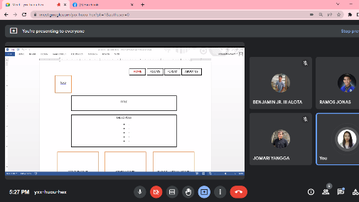 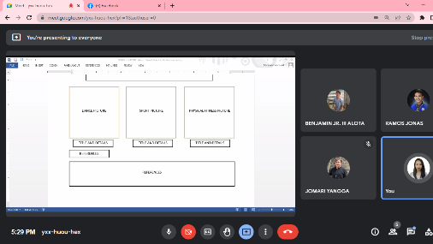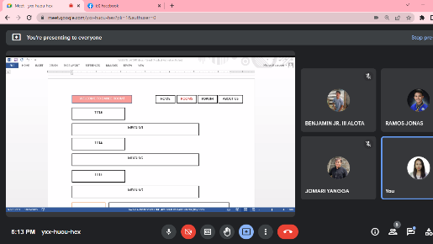

This happen during the presentation of proposed lay out of website design.

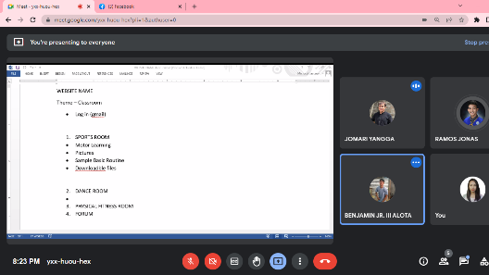 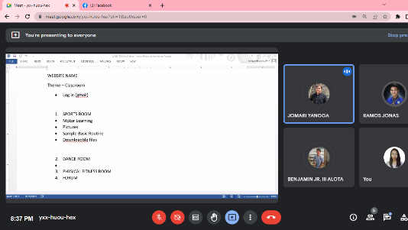

Presentation of duties and responsibilities as well as the content of website.

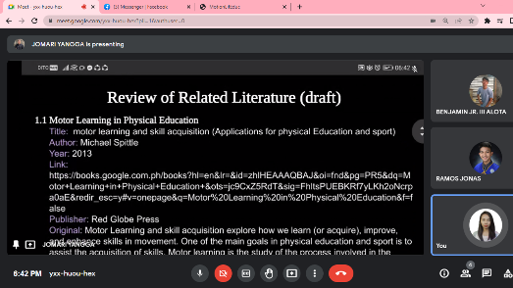 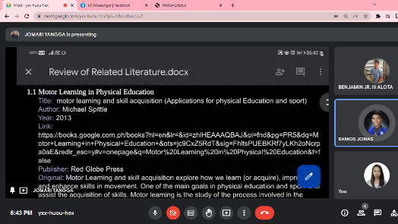

Checking of assigned duties and responsibilities.

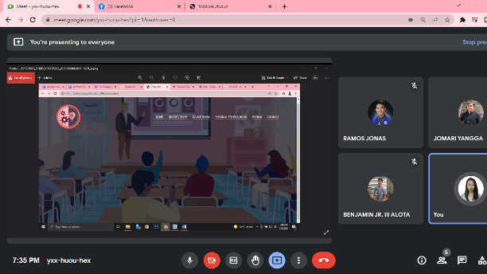

Presentation of initial website design.

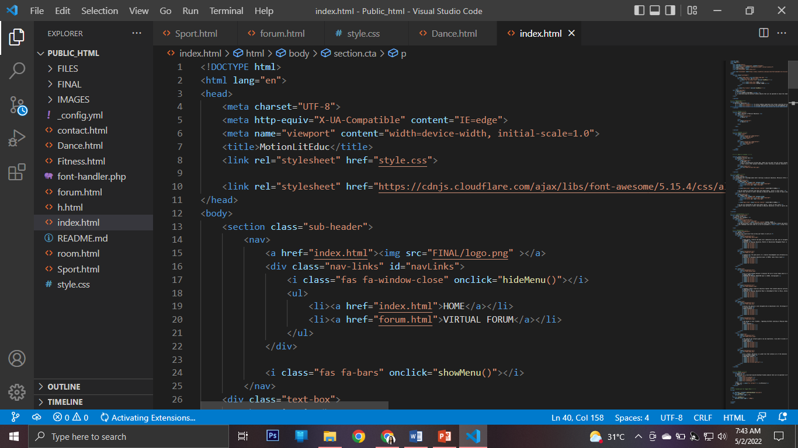 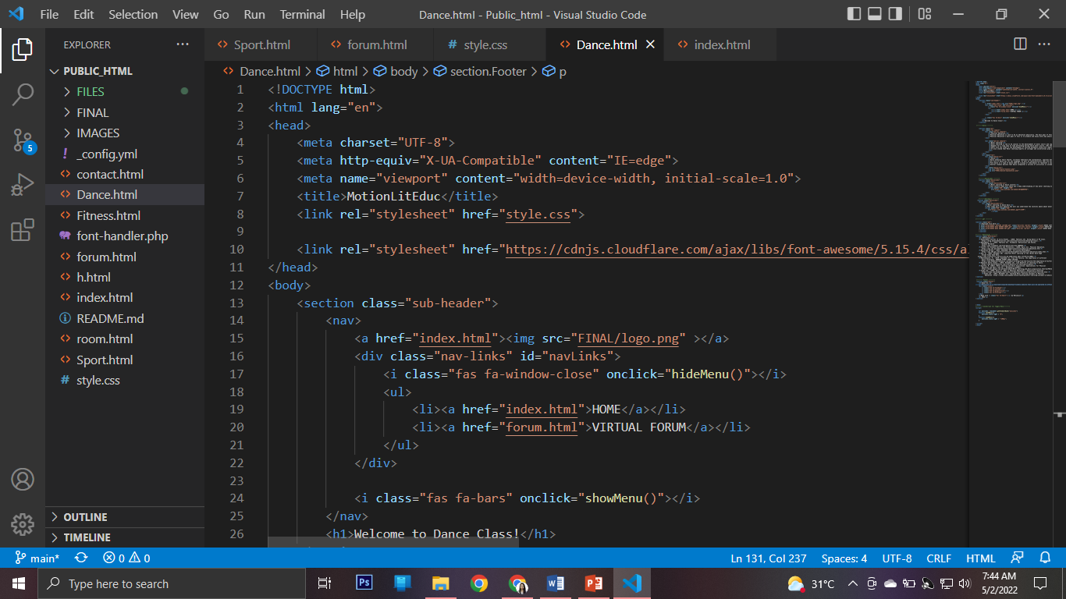 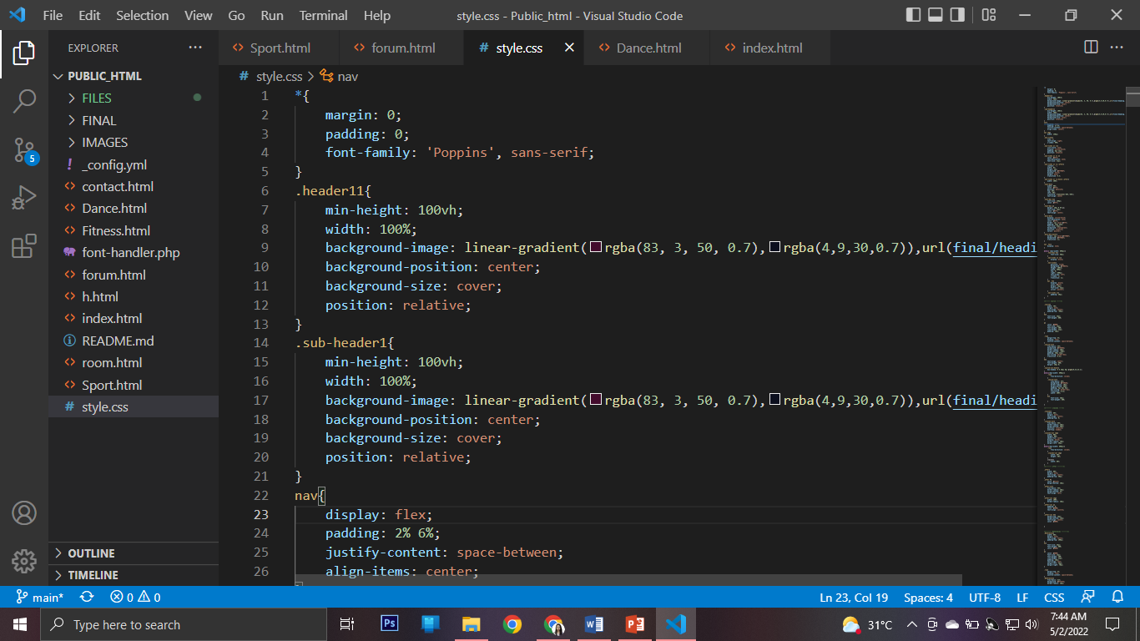

Codes in creating MotionLit website design.

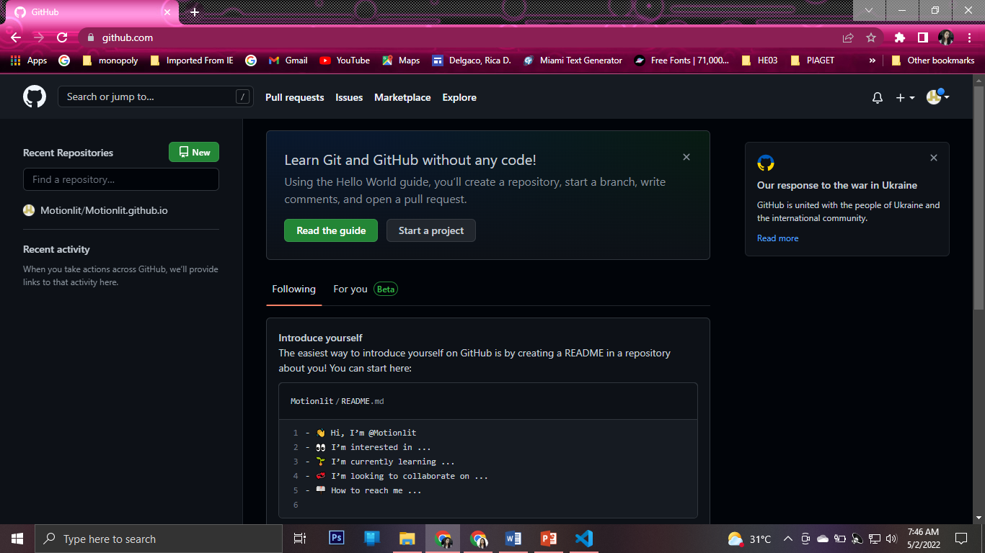 

Online publishing of MotionLit website.

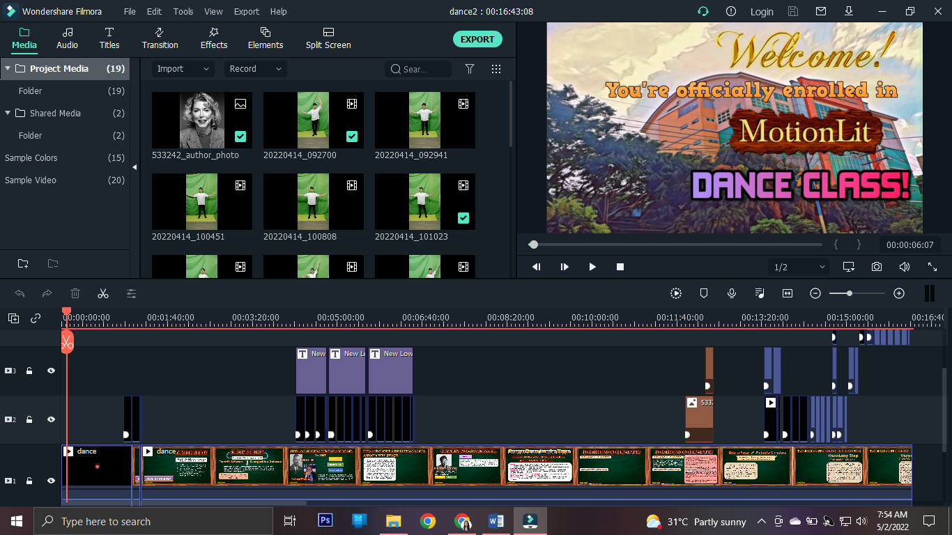 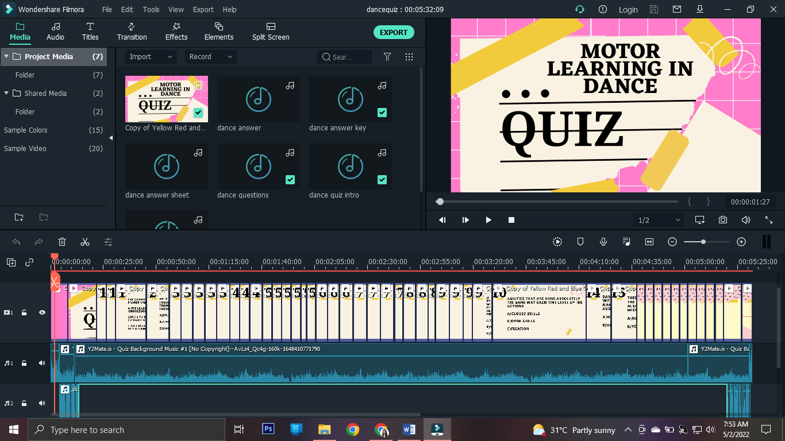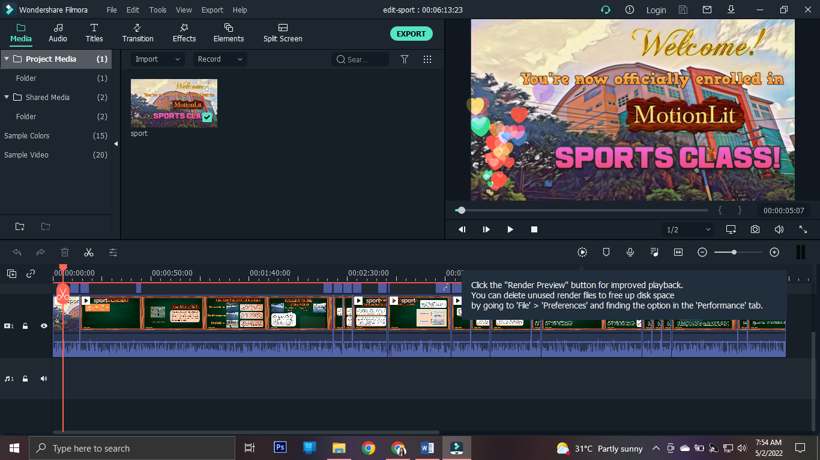 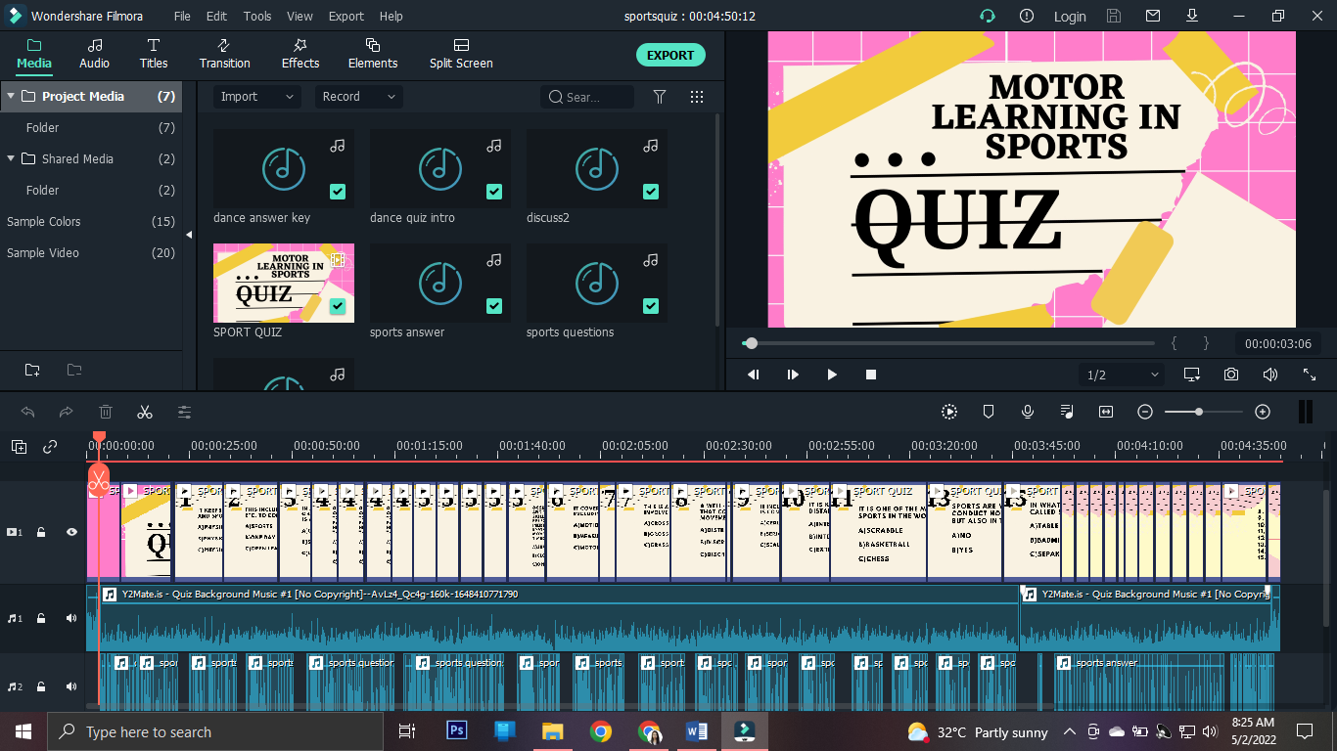

Video Editing MotionLit website lectures and quizzes.

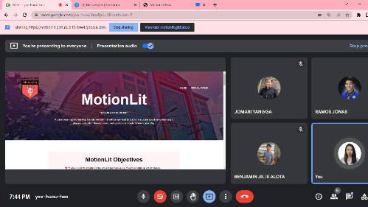 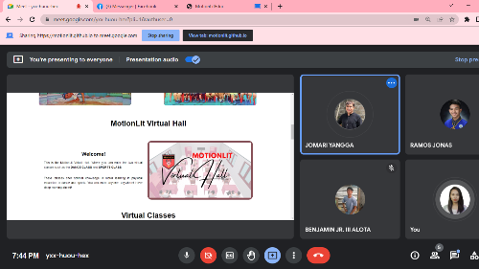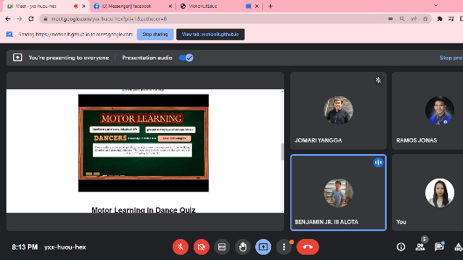

Presentation of final and actual MotionLit Website

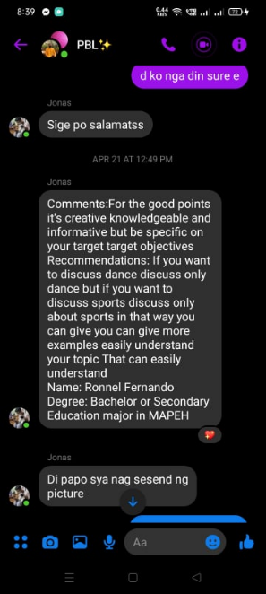 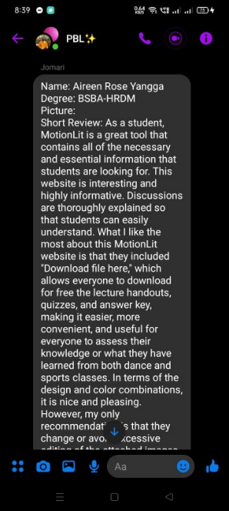 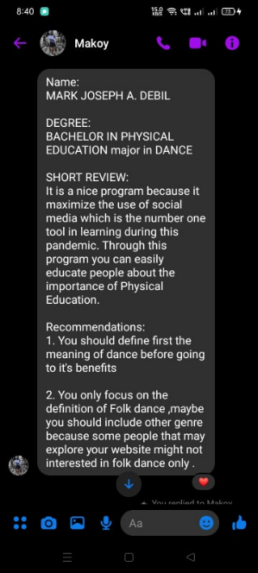 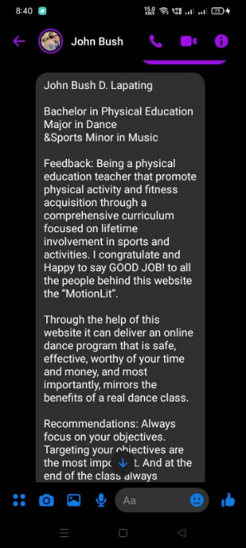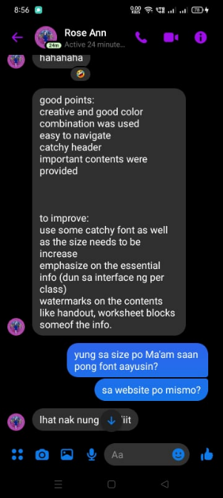 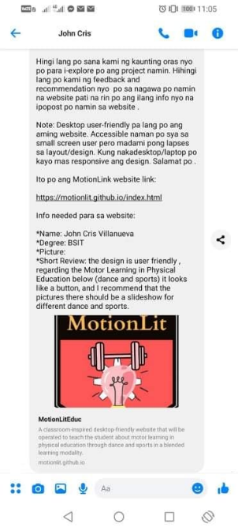 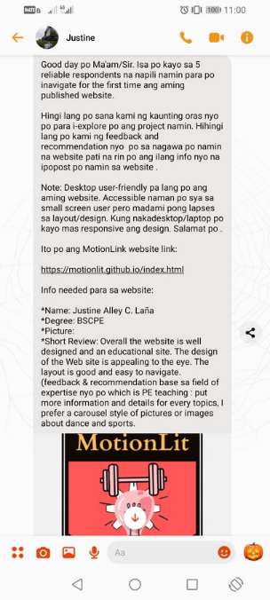

Conversation with interviewees and their feedbacks

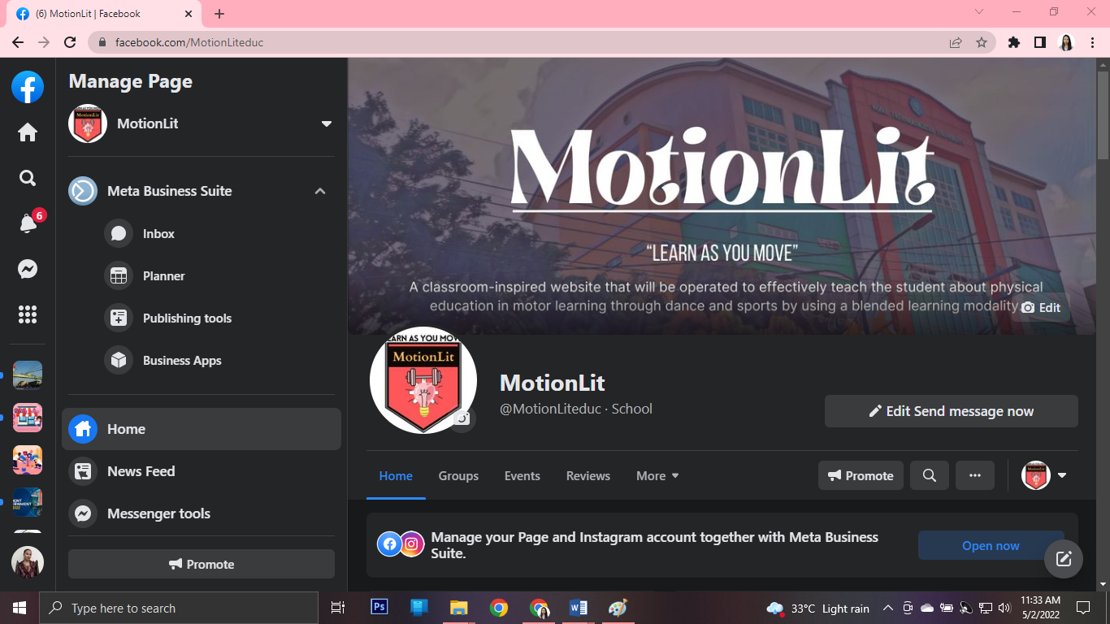 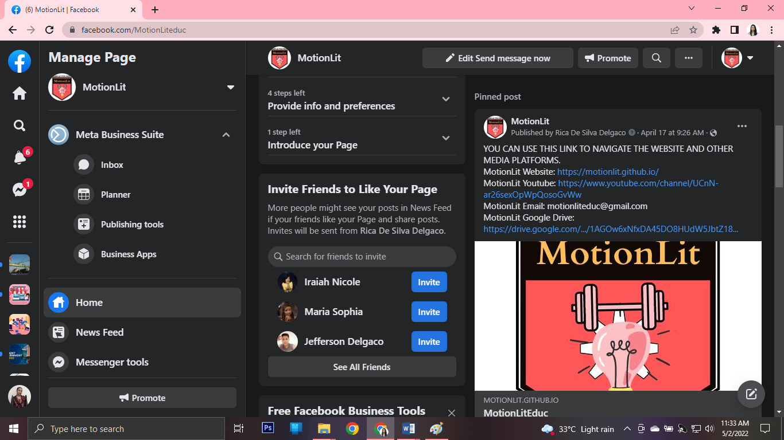 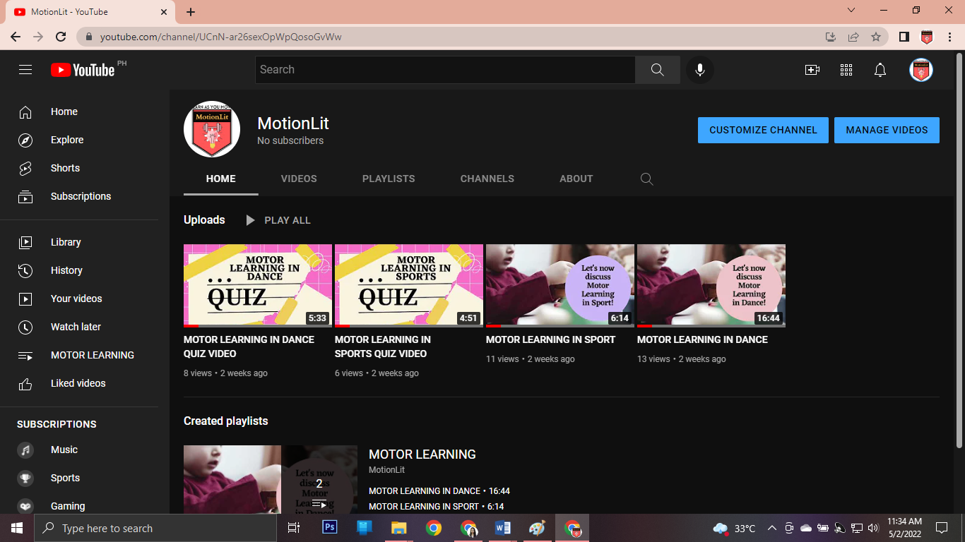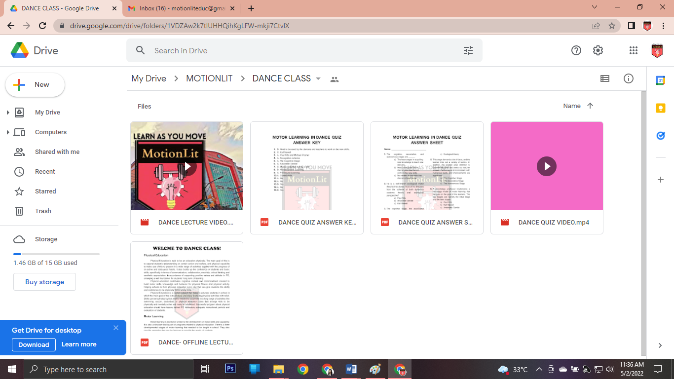 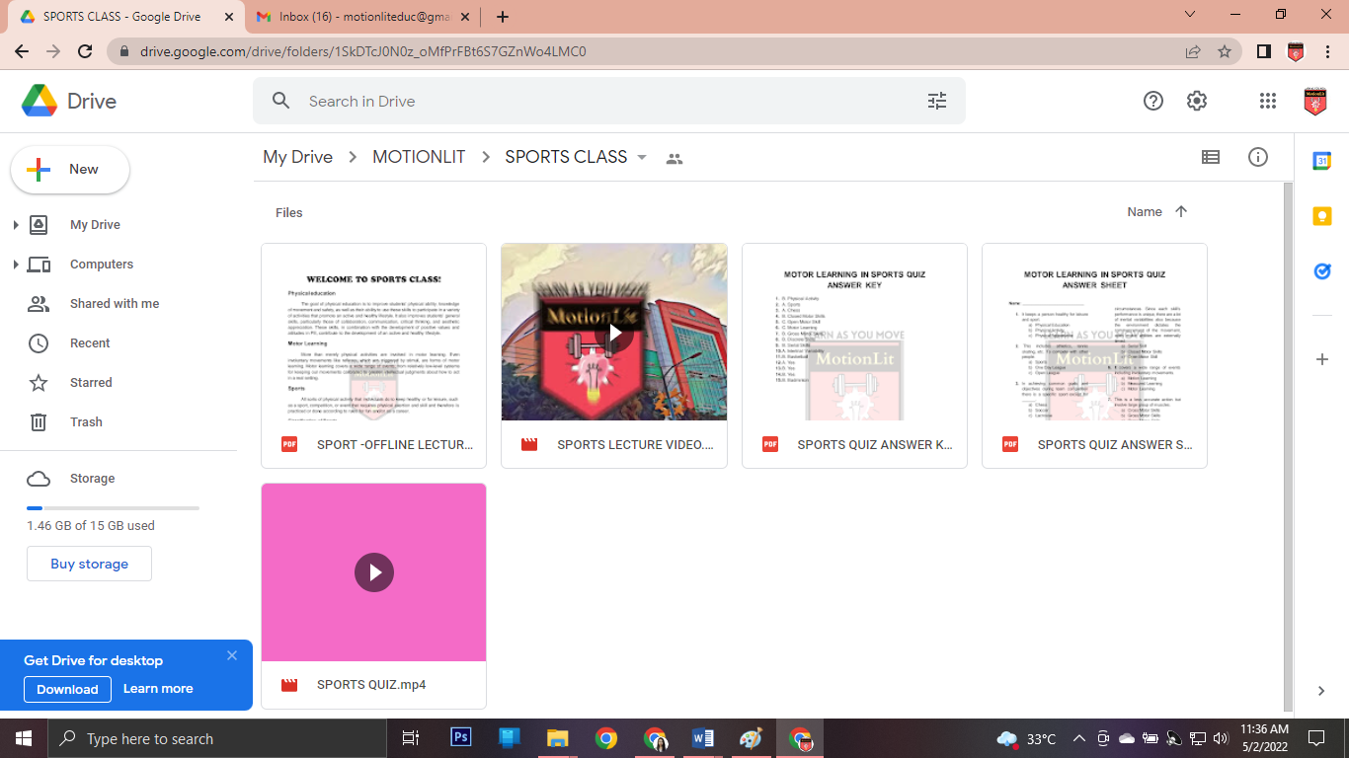 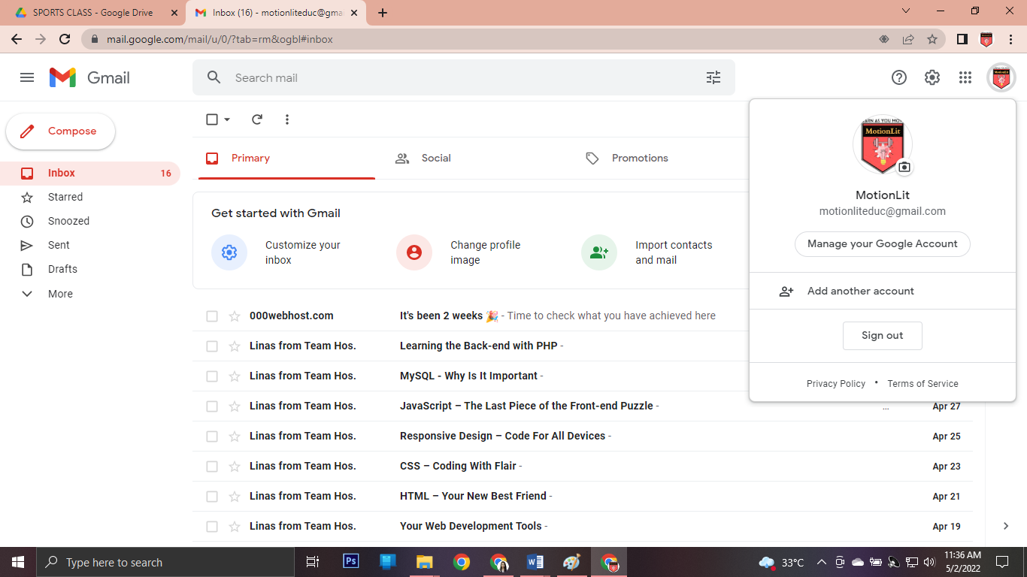

Different platforms embedded in MotionLit website.

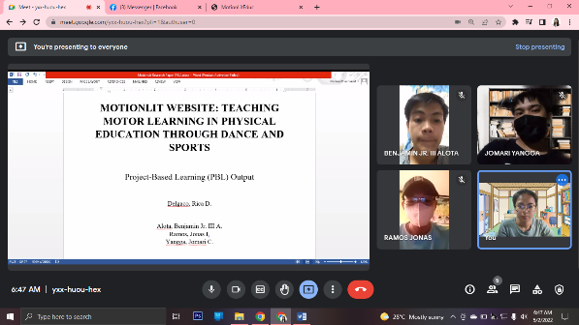 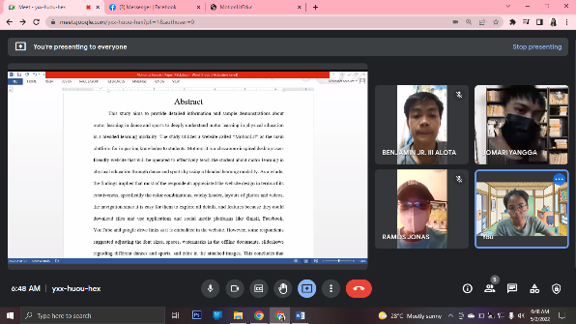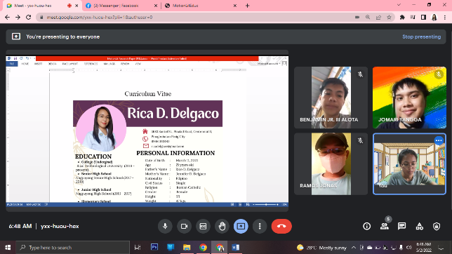

Presentation of finished research paper.

Curriculum Vitae

